Invisible Effects
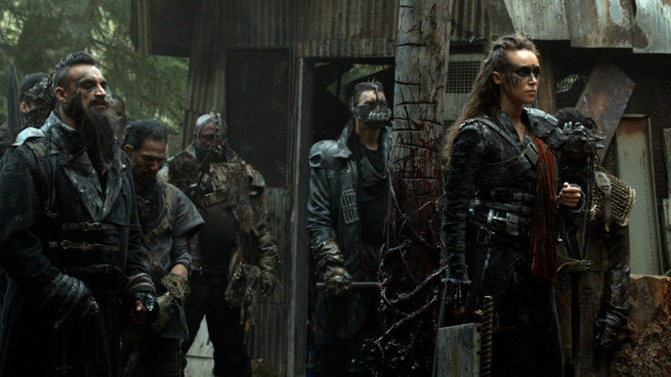
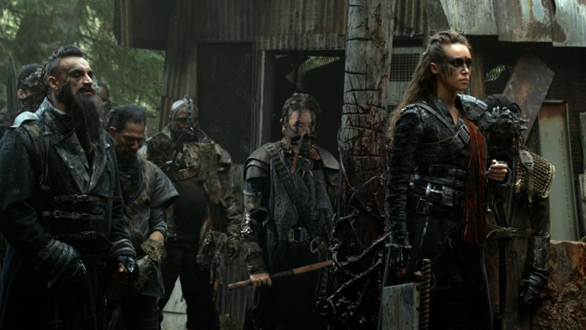

2D Tracking | Actor Paintout | Background Reconstruction | Keying | 2.5D Relighting | Roto | Grain Matching

Full Body Roto

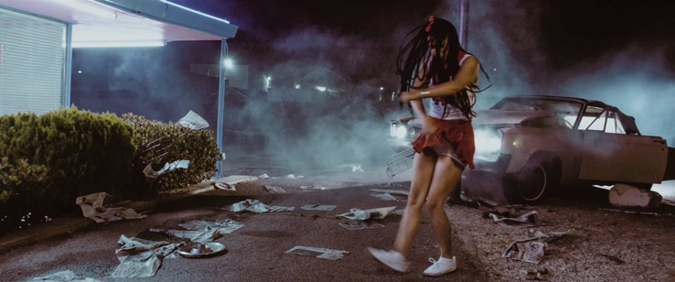

Logo Replacement
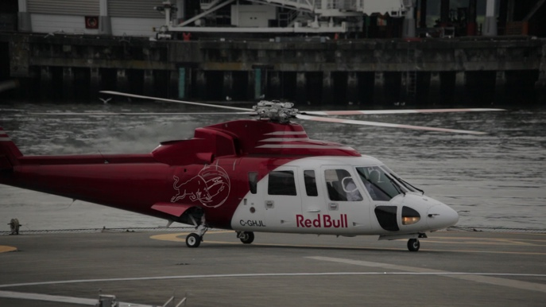
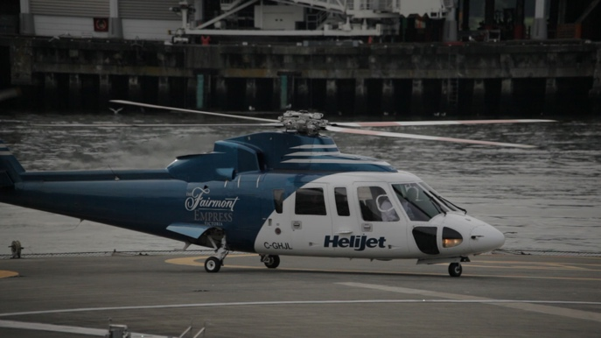

2D Tracking | Paintout | Logo Replacement | Adding Reflections | Hue Shift | Rotoscope | Grain Matching

Reflective Object

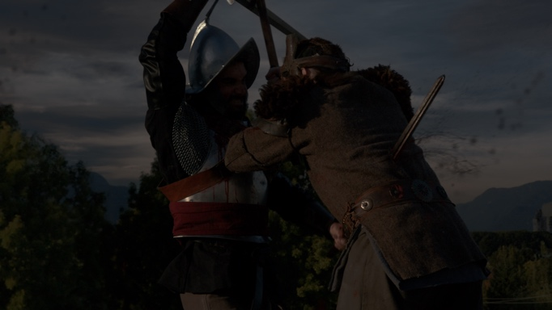
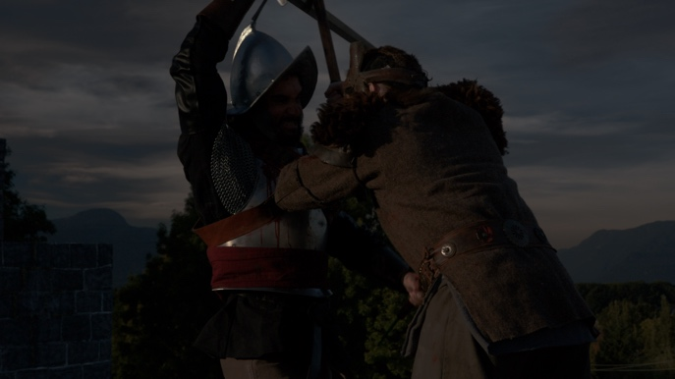

2D Tracking and Geo Tracking | CG Blade ( Texturing, Lighting, Animating, Rendering ) | Multipass Compositing | Digital Makeup | Gore Elements | Roto | Grain Matching

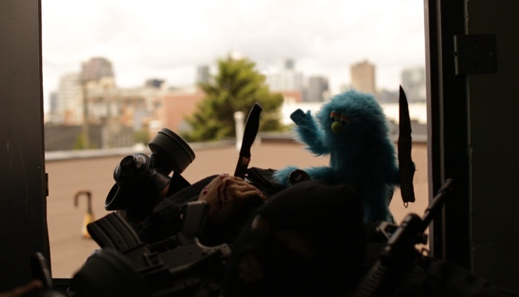
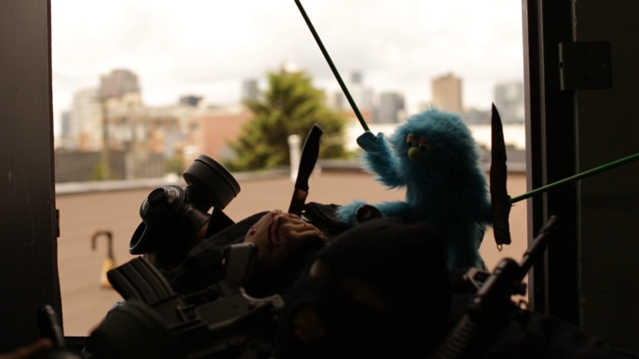
Rod Removal

Stabilization | Rod Paintout | Roto | Keying | Grain Matching | Match move

LOGO REPLACEMENT

Tracking | Paintout | Logo Replacement | Adding Reflections | Hue Shift | Rotoscope | Grain Matching

Reflection Paintout

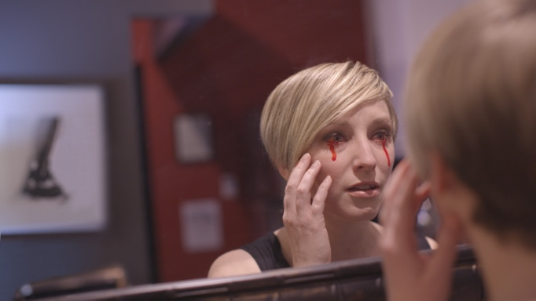
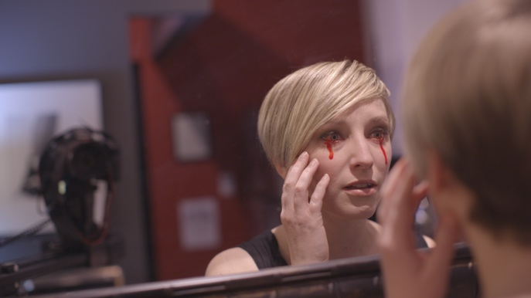

2D Tracking | Camera Paintout | Background Reconstruction | Roto | Grain Matching

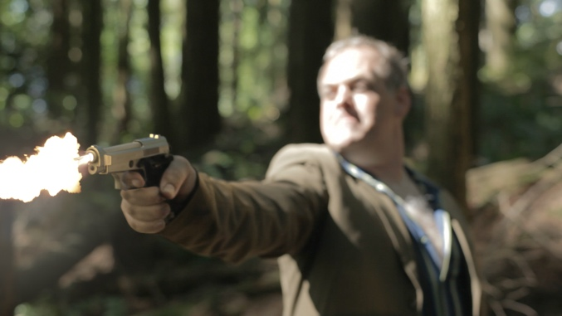
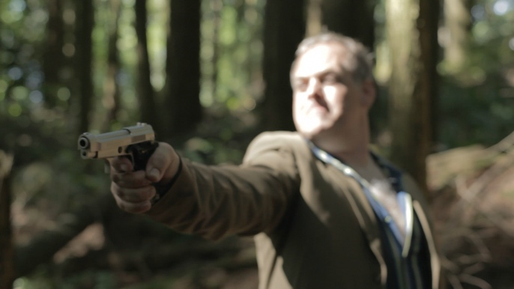
Muzzle Fire

2.5D Relighting | Muzzle Flash | Colour Correction

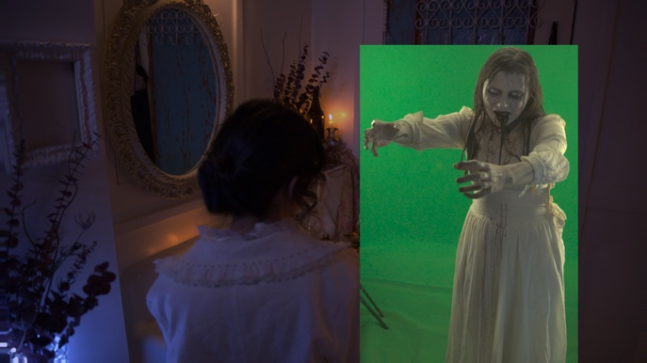
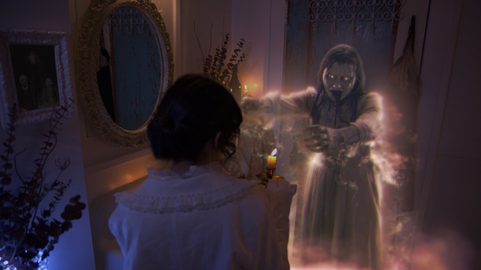
Ghost Project

Keying | 2D Tracking | Look Development | Stock Element Integration | Retiming | Interactive Lighting | Digital Set Decoration | Roto

Screen Burn In

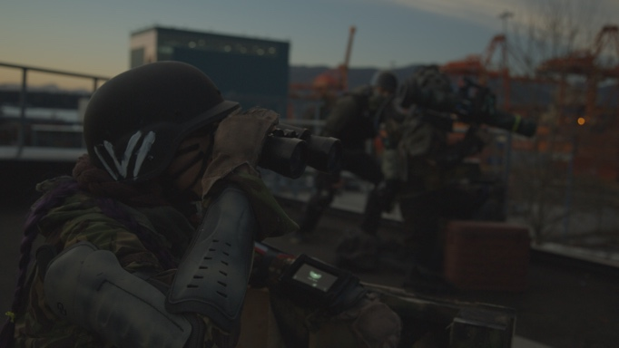
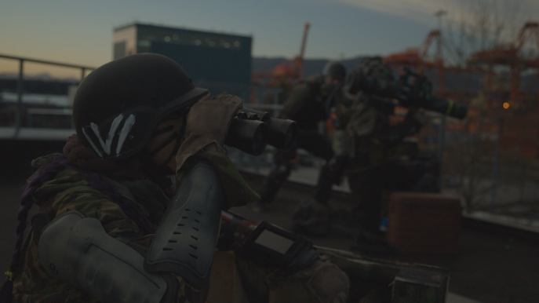

2D Tracking | Look Development | Retiming | Colour Correction | Roto

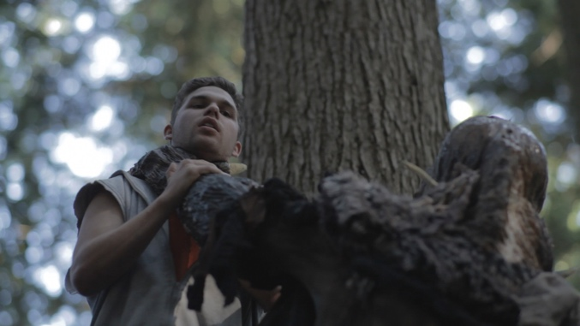
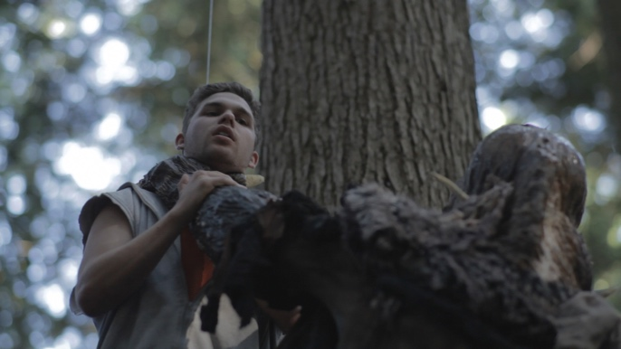
Wire Paintout

Frame by Frame Background Reconstruction | Background Patch | Roto

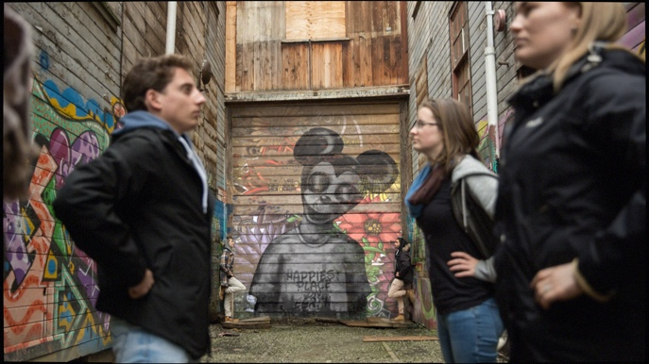
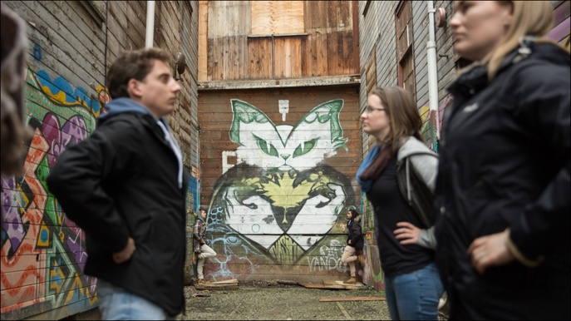
Title Project

2D Tracking | Wall Patch | Look Development | Colour Correction | Roto

